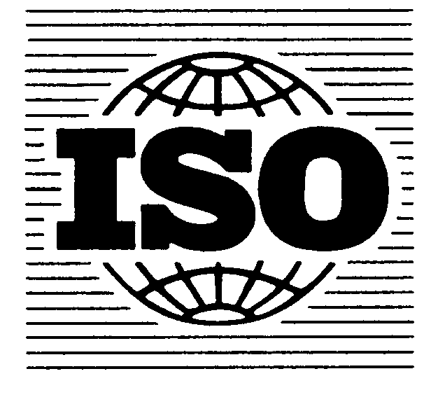 Secretariat of ISO/TC 147/SC 2/WG 52

Document ISO/TC 147/SC 2/WG 52
Date: 2010-10-19

Interlaboratory Trial for the validation of project ISO 17379:
Water quality — Determination of selenium
— Part 1: Method using hydride generation AFS (HG-AFS)
— Part 2: Method using hydride generation AAS (HG-AAS)

Registration form

for the participation in the validation trial

Matrix |  | Participation
Element |  | Yes  AFS | Yes  AAS | No
Se | Drinking Water
Se | Surface Water
Se | Waste Water

Contact person
Company name
Address

Country
E-mail
Phone
Fax
VAT ID (only for non German labs)
Date, Signature

Questionnaire
If you are interested to participate in the comparison, please fill in this questionnaire and registration form and send them together to address specified below:

Yes No
Do you measure Se AAS or AFS routinely?
How many measurements are you
performing the year? (Please enter the number)
In how many PT schemes for these elements
do you participate the year? (Please enter the number)
Is your laboratory accredited according to ISO 17025
for the measurement of the elements considered here?

Please return the filled-in registration form together with the filled-in questionnaire until 15th December 2010 to:

Contact details of the Interlab organiser:

Ulrich Borchers
c/o IWW Water Centre
Department Water Quality
Moritzstrasse 26
D – 45476 Muelheim an der Ruhr
GERMANY

Phone: +49 208 40303 210
Fax: +49 208 40303-80
e-mail: u.borchers@iww-online.de

